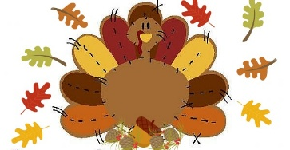


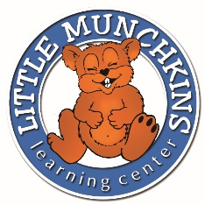
Little Munchkins Learning Center
This Photo by Unknown Author is licensed under CC BY


“Where learning and loving go hand in hand”
Calia S 11/15 Bowen V 11/22
Jackson P 11/11 Alex R 11/18
Somhie C 11/22 Dexter P 11/11
Maeve M 11/26 Emry W 11/22
LaDarrian T 11/24 Kayla B 11/26
Stella R 11/11
November Birthdays
Monthly Newsletter November 2026

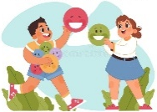
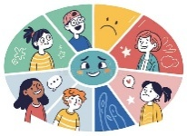
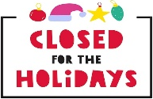

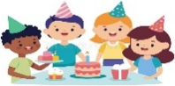

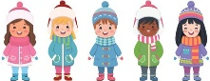
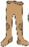
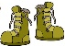
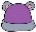
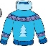
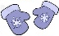
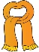



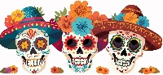
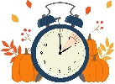
REMINDER: We will be CLOSED Nov. 26th-27th for Thanksgiving, Dec. 23rd-25th for Christmas & Dec. 31st-Jan. 1st for New Years
Extra Clothes Reminder
Please make sure your child(ren)’s cubby is stocked with weather-appropriate clothing at all times. Each child must have at least three complete changes of clothing, including shirts, pants/shorts, socks, and a pair of tennis shoes. As the weather changes, please check your child’s cubby and replace any clothing that is no longer appropriate for the season. Thank you for helping us keep your little ones comfortable and prepared throughout the day!

The Importance of Social-Emotional Development
Social-emotional development is an important part of your child's growth! It helps children learn to understand their feelings, build healthy relationships, communicate their needs, and interact positively with others. Through everyday experiences at daycare, children practice sharing, taking turns, showing kindness, and learning how to manage big emotions.
How can we support social-emotional development?
Children develop these skills at different ages and stages. Infants build trust and security through loving interactions with caregivers. Toddlers begin expressing their feelings, exploring independence, and learning to play alongside others. Preschoolers practice sharing, cooperating, developing friendships, and using their words to solve problems. As children grow, they become better at recognizing emotions, showing empathy, resolving disagreements, and working together.
How can you help at home?
Parents can support social-emotional development by talking about feelings, modeling kindness, encouraging children to use their words, and praising positive behaviors. Reading books about emotions, playing turn-taking games, and allowing children to make age-appropriate choices are also wonderful ways to build these skills.
Remember, learning to manage emotions takes time and practice! Children will not always know how to express themselves appropriately, and that is okay. With patience, encouragement, and consistent guidance from both parents and teachers, children can develop the confidence and social skills they need to build meaningful relationships and succeed as they grow.

Looking Ahead
Nov 1st – Daylight Savings End
Nov 2nd – Day of the Dead
Nov 3rd – Election Day
Nov 11th – Picture Day for Infants, Toddlers, 2’s & Siblings
Nov 12th – 3’s, 4’s, 5’s & Makeups
Nov 26th-27th – Closed for Thanksgiving




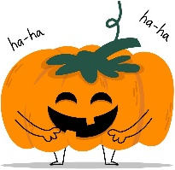
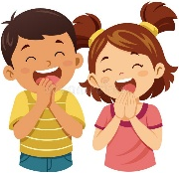
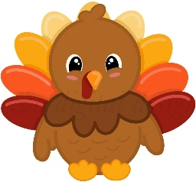
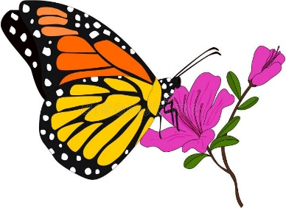
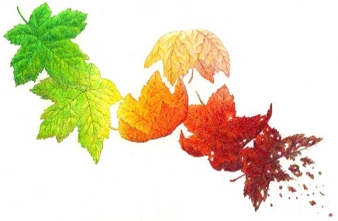
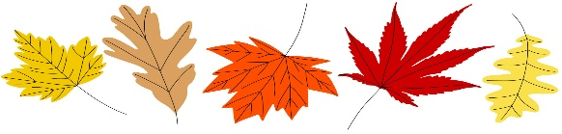
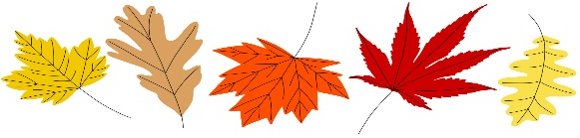
Crystal’s corny corner
- What’s the most musical part of the Turkey?
The drumstick!
- What do you call a pretty pumpkin?
Gourdgeous!
- Why did the cranberry turn red?
It saw the turkey getting dressed!
Smart Snippets
- Did you know that turkeys can change colors when they get excited, scared, or upset? The skin on a turkey’s head and neck can change between shades of red, blue, white, and even purple! This happens because turkeys have blood vessels close to the surface of their skin. When blood flow changes, their skin changes color, almost like a person blushing when they feel embarrassed. Male turkeys, called toms, often have especially noticeable color changes when they are showing off to attract a mate or when they feel threatened. Their colorful heads help communicate how they are feeling to other turkeys!
- During the fall, including November, millions of monarch butterflies from eastern North America migrate south to the mountains of Mexico, where they spend the winter in warmer conditions. Some travel as far as 3,000 miles! What makes their journey even more amazing is that the monarchs that begin the fall migration are not the same butterflies that return north in the spring. A special generation, often called the super generation, lives much longer than other monarchs and can survive for several months to complete the journey and spend the winter. In the spring, they begin traveling north and lay eggs along the way. Their great-grandchildren may eventually make the return trip north!
- When leaves fall from trees during autumn, they begin to break down through a natural process called decomposition. Tiny organisms, such as fungi, bacteria, and earthworms, help turn the leaves into nutrient-rich organic matter that supports plant growth. Fallen leaves also act like a natural blanket, helping protect plant roots from temperature changes and keeping moisture in the soil. They provide shelter for insects, worms, and other small creatures during the colder months. This natural recycling process returns important nutrients to the earth, helping trees, flowers, and other plants grow healthy and strong. So, the next time you see a pile of autumn leaves, remember that they are doing more than making the ground colorful—they are helping nature thrive!

